# Data warehousing and BI systems

**Author:**

[First and last name]: Paloma Barreiros

[Academic year and term]: 3 year

1. The aims of data warehouse implementation

This chapter should contain the list of aims that have to be achieved through the implementation of the data warehouse in the chosen part of reality. All defined aims should determine the further facts, dimensions and measures.

The list of aims that have to be achieved through the implementation of this data warehouse are:

A Fact Table contains:

* Measurements/facts
* Foreign key to dimension table

A Dimension Table contains:

* A dimension table contains dimensions of a fact.
* They are joined to fact table via a foreign key.
* Dimension tables are de-normalized tables.
* The Dimension Attributes are the various columns in a dimension table
* Dimensions offers descriptive characteristics of the facts with the help of their attributes
* No set limit set for given for number of dimensions
* The dimension can also contain one or more hierarchical relationships

1. Conceptual model of data warehouse

This chapter should contain:

* **the graphical presentation of relationships between the fact and dimensions (in form of diagram – use star model for this diagram); if you have many facts, prepare the diagram for every fact separately;**



* **one or many hierarchies for every dimension, presented in graphical form (name every level for particular hierarchies),**



* **list of measures for every fact.**

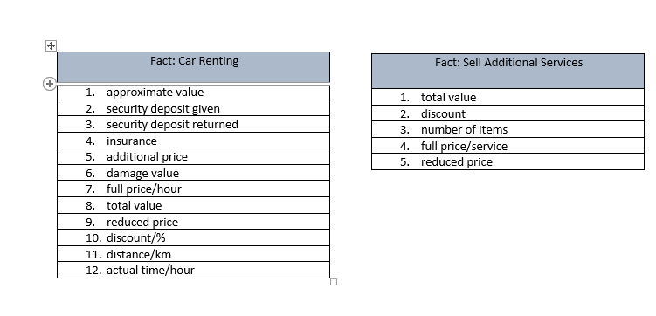

1. Database structure of data warehouse

This chapter should contain the diagram, which presents the fact tables, dimension tables and relationships between them. Additionally, every table has to be defined by:

* the detailed list of columns (column name),
* primary key,
* foreign key in fact table(s) and optionally in dimension tables.

The diagram should be prepared using the star or snowflake data model (choose one of them).

